

**JSC “Kazakh British Technical University”**

**Faculty of Information Technology**

**Microprocessor Control Systems**

**Laboratory Work #5**

**Prepared by: Maratuly Temirbolat**

**Almaty 2021**

**Task and solving in Unity Pro:**

The current task of the Laboratory Work is to create the doors with 3 different modes: automatic, manual and stop ones. The doors also have directions in which they need to go. The automatic part of the modes works just pressing it once then the doors start opening, while it is opened the timer is begun from 0s to 1m. Once the timer reaches 1minute the doors then begin to close. The manual mode works as owner wants but the procedure of closing and opening can be done only by him. The stope mode is responsible for the occasion when there is a need to stop the work of the doors.

**Table of the variables with data types:**

All the variables:

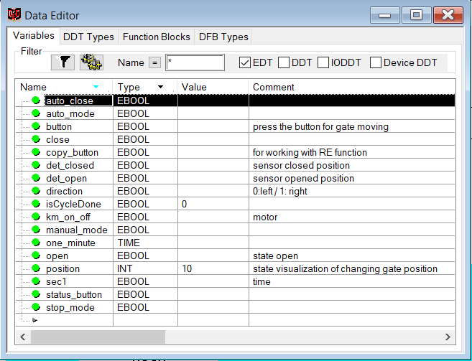

**The used variables of them:**

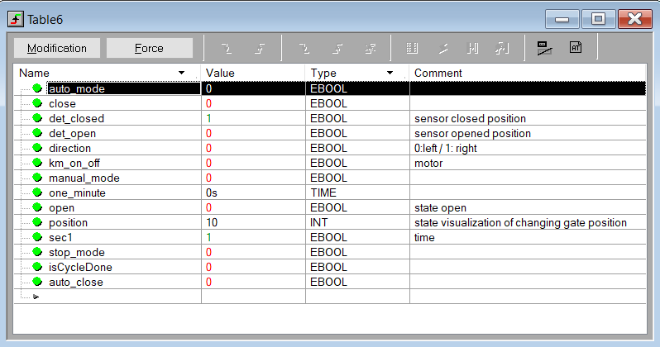

**The code of the doors:**

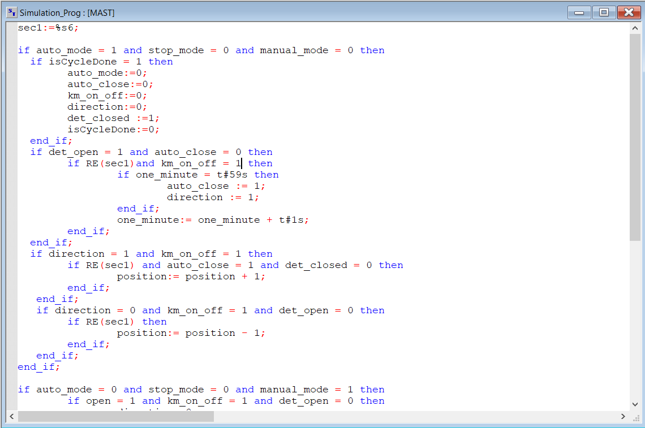

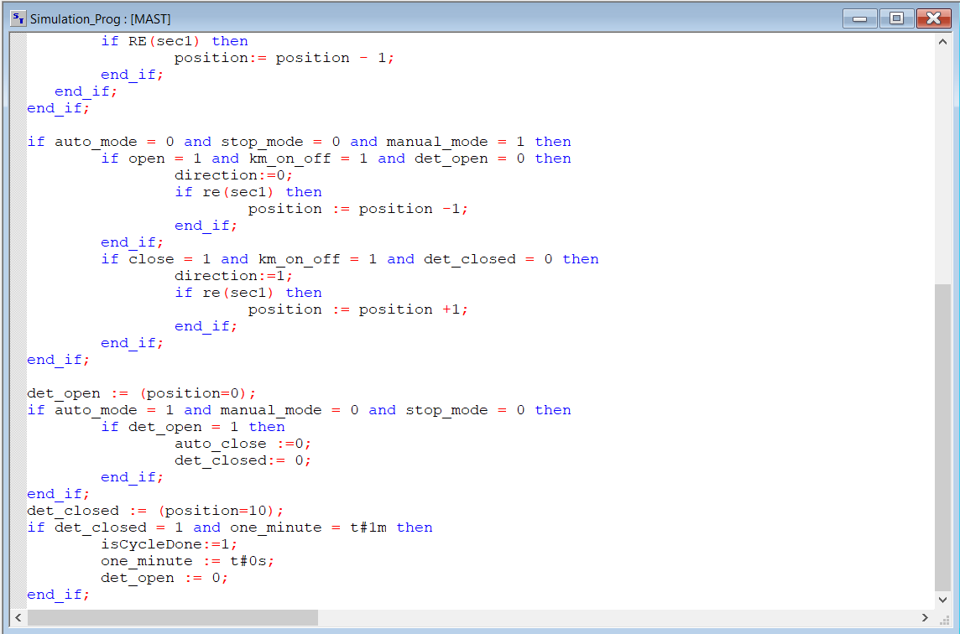

**The working screen of the doors:**

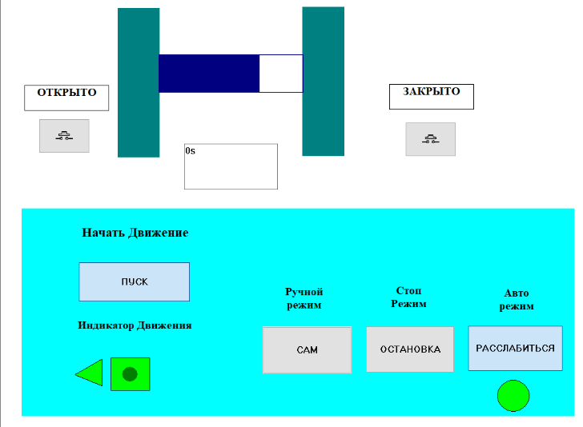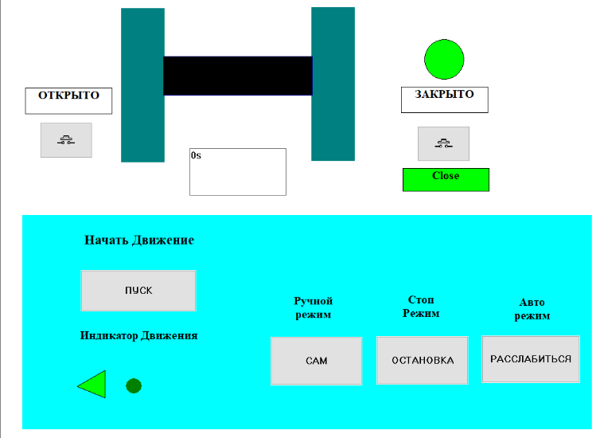

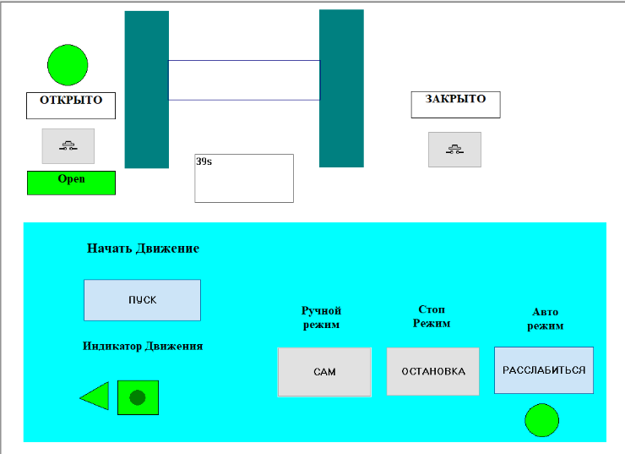

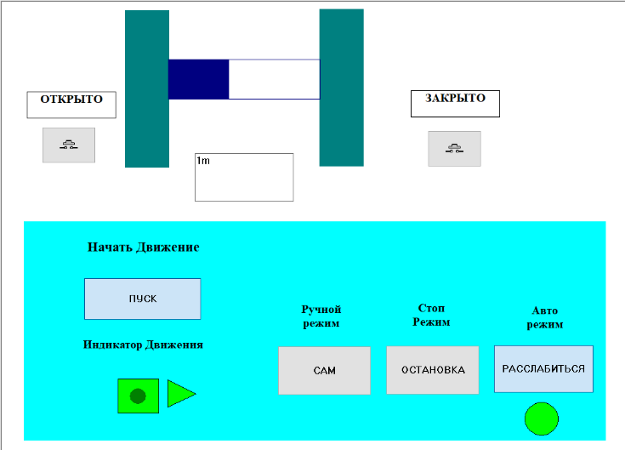

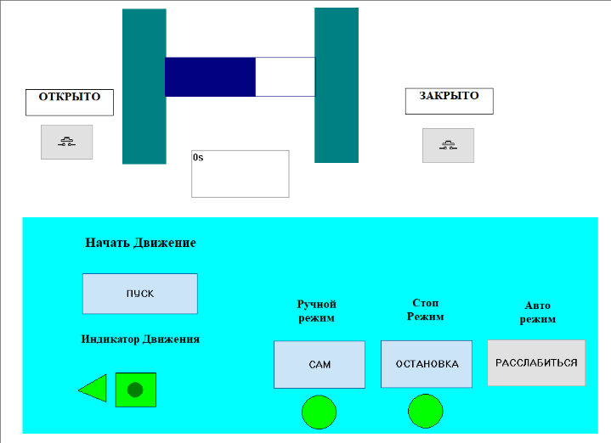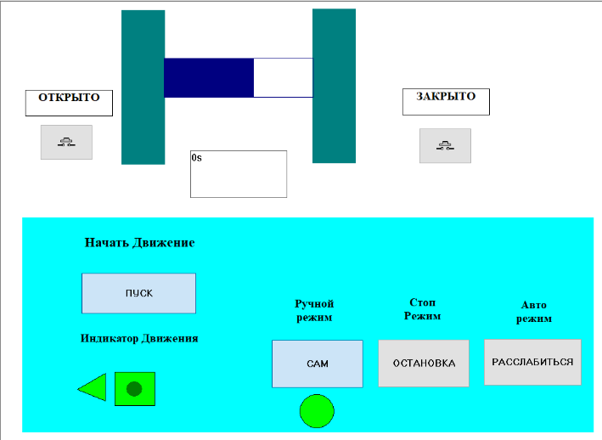

**Conclusion:**

During the Laboratory work we got acquainted with a more complex construction of coding for working on automatic doors. This time automatic, manual as well as stop modes are added for the doors. We used the rectangular, circles, buttons, text boxes in order to illustrate doors, walls, indicators, the appropriate information about the stages respectively. While the process there was also created remote control which begins the work of the engine and also shows whether it works or not as well as direction of the motion of the doors just lighting the needed triangle. The direction of the action is also reflected by the circles in left and right parts of the screen’s picture where the left upper circle demonstrates the motion to the left and right upper illustrates the right motion.